# 

Homework: Next Date

# 

**Group 12 Members:**

Brandon Ho - 100754357

Rupam Mittal - 100640634

**Course:** SOFE3980U

**Date:** 2024/02/27

**Professor:** Mohamed El-Darieby

## 1. follow our algorithm to design test cases and group them in a test case table (chapter 6 of the book). Highlight characteristics, domains, blocks, values. Use the pairwise coverage criteria.

| **Partition** | **Description** | **Valid Inputs** | **Invalid Inputs** |
| --- | --- | --- | --- |
| day | Days in a week | **February:** 1 - 28  **February Leap Year:** 1 - 29  **April, June, Sept, Nov:** 1 - 30  **All other months:** 1 - 31 | 0, negative values, >31 |
| month | Months in a year | 1 - 12 | 0, negative values, >12 |
| year | Years between 1812 and 2212 | 1812 - 2212 | <1812, >2212, negative values |

The domain for days has several conditions involving leap years and set amounts of days in certain months. The number of months in a year are static and independent. The domain for years is given as 1812 - 2212.

## 2. write a Junit test script

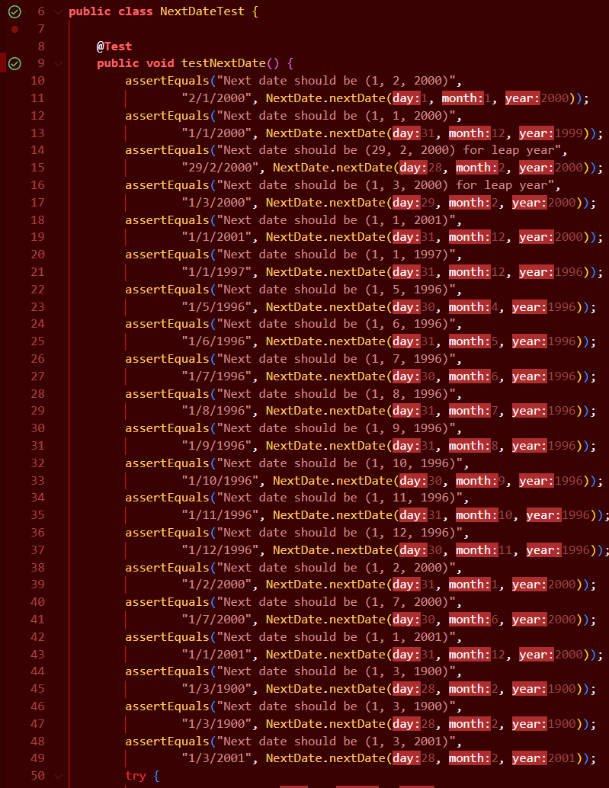

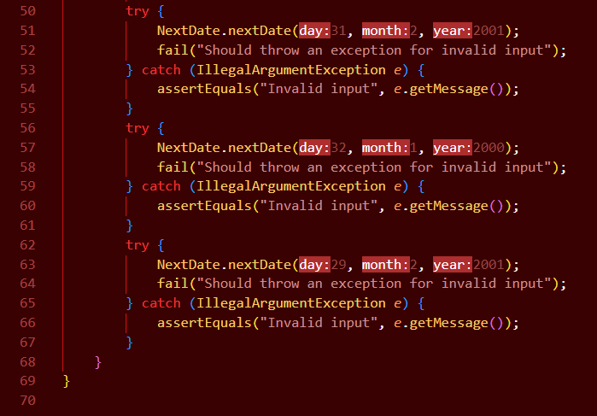

## 3. write the corresponding java code

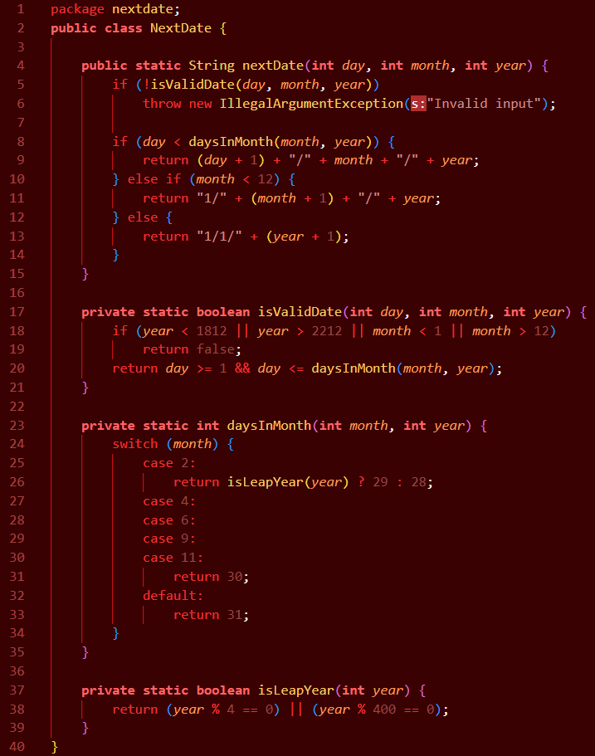

## 4-5. Run the tests and debug if need be. Repeat until the quality of the code is assured

